Project 3 Analysis
Marshall Roll
2026-04-20
library(tidyverse)
## Warning: package 'ggplot2' was built under R version 4.5.3
## ── Attaching core tidyverse packages ──────────────────────── tidyverse 2.0.0 ──
## ✔ dplyr 1.1.4 ✔ readr 2.1.5
## ✔ forcats 1.0.0 ✔ stringr 1.5.1
## ✔ ggplot2 4.0.2 ✔ tibble 3.3.0
## ✔ lubridate 1.9.4 ✔ tidyr 1.3.1
## ✔ purrr 1.1.0
## ── Conflicts ────────────────────────────────────────── tidyverse_conflicts() ──
## ✖ dplyr::filter() masks stats::filter()
## ✖ dplyr::lag() masks stats::lag()
## ℹ Use the conflicted package (<http://conflicted.r-lib.org/>) to force all conflicts to become errors
library(survival)
## Warning: package 'survival' was built under R version 4.5.3
library(survminer)
## Warning: package 'survminer' was built under R version 4.5.3
## Loading required package: ggpubr
## Warning: package 'ggpubr' was built under R version 4.5.3
##
## Attaching package: 'survminer'
##
## The following object is masked from 'package:survival':
##
## myeloma
library(glmnet)
## Warning: package 'glmnet' was built under R version 4.5.2
## Loading required package: Matrix
##
## Attaching package: 'Matrix'
##
## The following objects are masked from 'package:tidyr':
##
## expand, pack, unpack
##
## Loaded glmnet 4.1-10
library(gtsummary)
## Warning: package 'gtsummary' was built under R version 4.5.2
library(cowplot)
##
## Attaching package: 'cowplot'
##
## The following object is masked from 'package:ggpubr':
##
## get_legend
##
## The following object is masked from 'package:lubridate':
##
## stamp
library(naniar)
## Warning: package 'naniar' was built under R version 4.5.2
library(flextable)
##
## Attaching package: 'flextable'
##
## The following object is masked from 'package:gtsummary':
##
## continuous_summary
##
## The following objects are masked from 'package:ggpubr':
##
## border, font, rotate
##
## The following object is masked from 'package:purrr':
##
## compose
# Raw data stored locally in Documents\Advanced_Methods_Roll\Project 3\Code
heart_raw <- read_csv("../DataRaw/frmgham2.csv")
## Rows: 11627 Columns: 39
## ── Column specification ────────────────────────────────────────────────────────
## Delimiter: ","
## dbl (39): RANDID, SEX, TOTCHOL, AGE, SYSBP, DIABP, CURSMOKE, CIGPDAY, BMI, D...
##
## ℹ Use `spec()` to retrieve the full column specification for this data.
## ℹ Specify the column types or set `show_col_types = FALSE` to quiet this message.

Data Cleaning
# n = 4434
heart <- heart_raw %>%
filter(PERIOD == 1) %>% #baseline covariates
filter(PREVSTRK != 1) %>% #exclude prior stroke # n = 4402
mutate(time_stroke_yrs = TIMESTRK/365.25) %>% # Convert time stroke to years
mutate(
time_stroke_yrs = pmin(time_stroke_yrs, 10),
censored = ifelse(time_stroke_yrs < 10, 1, 0),
SEX = case_when(SEX == 1 ~ "Male",
SEX == 2 ~ "Female"),
HIGHBP = ifelse(SYSBP >= 160, 1, 0)
)
heart_male <- heart %>% filter(SEX == "Male") # n = 1930
heart_female <- heart %>% filter(SEX == "Female") # n = 2472

Table 1
heart %>%
tbl_summary(
by = SEX,
include = c(AGE, SYSBP, DIABP, HIGHBP, TOTCHOL, CURSMOKE, BMI, DIABETES,
BPMEDS, PREVCHD, PREVMI, STROKE, HOSPMI, DEATH, time_stroke_yrs),
statistic = list(
all_continuous() ~ "{mean} ({sd})",
all_categorical() ~ "{n} ({p}%)"
),
digits = all_continuous() ~ 2,
label = list(
AGE = "Age",
SYSBP = "Systolic BP",
DIABP = "Diastolic BP",
HIGHBP = "High Systolic BP (≥160)",
CURSMOKE = "Smoker",
TOTCHOL = "Total Cholesterol (mg/dL)",
DIABETES = "Diabetes",
BPMEDS = "Blood Pressure Medication",
PREVCHD = "Coronary Heart Disease",
PREVMI = "Past MI",
STROKE = "10-year Stroke",
HOSPMI = "10-year MI",
DEATH = "10-year Death",
time_stroke_yrs ~ "Follow-up Time (Years)"
),
missing_text = "(Missing)"
) %>%
add_overall()
Characteristic | Overall N = 4,402¹ | Female N = 2,472¹ | Male N = 1,930¹
Age | 49.88 (8.66) | 49.99 (8.63) | 49.73 (8.71)
Systolic BP | 132.76 (22.32) | 133.66 (24.33) | 131.60 (19.40)
Diastolic BP | 83.03 (12.01) | 82.53 (12.41) | 83.66 (11.44)
High Systolic BP (≥160) | 524 (12%) | 353 (14%) | 171 (8.9%)
Total Cholesterol (mg/dL) | 237.01 (44.65) | 239.70 (46.19) | 233.62 (42.39)
(Missing) | 52 | 45 | 7
Smoker | 2,169 (49%) | 1,001 (40%) | 1,168 (61%)
BMI | 25.83 (4.08) | 25.57 (4.52) | 26.17 (3.40)
(Missing) | 17 | 13 | 4
Diabetes | 119 (2.7%) | 60 (2.4%) | 59 (3.1%)
Blood Pressure Medication | 136 (3.1%) | 96 (3.9%) | 40 (2.1%)
(Missing) | 60 | 38 | 22
Coronary Heart Disease | 187 (4.2%) | 67 (2.7%) | 120 (6.2%)
Past MI | 82 (1.9%) | 14 (0.6%) | 68 (3.5%)
10-year Stroke | 383 (8.7%) | 204 (8.3%) | 179 (9.3%)
10-year MI | 450 (10%) | 132 (5.3%) | 318 (16%)
10-year Death | 1,525 (35%) | 694 (28%) | 831 (43%)
Follow-up Time (Years) | 9.51 (1.67) | 9.60 (1.54) | 9.40 (1.82)
¹Mean (SD); n (%)

Missing Data
## No super high rates of stroke among missing data levels
heart %>%
group_by(is.na(BPMEDS), SEX) %>%
summarize(Stroke = sum(STROKE), prop_stroke = sum(STROKE)/n())
## `summarise()` has grouped output by 'is.na(BPMEDS)'. You can override using the
## `.groups` argument.
## # A tibble: 4 × 4
## # Groups: is.na(BPMEDS) [2]
## `is.na(BPMEDS)` SEX Stroke prop_stroke
## <lgl> <chr> <dbl> <dbl>
## 1 FALSE Female 200 0.0822
## 2 FALSE Male 177 0.0928
## 3 TRUE Female 4 0.105
## 4 TRUE Male 2 0.0909
heart %>%
group_by(is.na(BMI), SEX) %>%
summarize(Stroke = sum(STROKE), prop_stroke = sum(STROKE)/n())
## `summarise()` has grouped output by 'is.na(BMI)'. You can override using the
## `.groups` argument.
## # A tibble: 4 × 4
## # Groups: is.na(BMI) [2]
## `is.na(BMI)` SEX Stroke prop_stroke
## <lgl> <chr> <dbl> <dbl>
## 1 FALSE Female 204 0.0830
## 2 FALSE Male 178 0.0924
## 3 TRUE Female 0 0
## 4 TRUE Male 1 0.25
heart %>%
group_by(is.na(TOTCHOL), SEX) %>%
summarize(Stroke = sum(STROKE), prop_stroke = sum(STROKE)/n())
## `summarise()` has grouped output by 'is.na(TOTCHOL)'. You can override using
## the `.groups` argument.
## # A tibble: 4 × 4
## # Groups: is.na(TOTCHOL) [2]
## `is.na(TOTCHOL)` SEX Stroke prop_stroke
## <lgl> <chr> <dbl> <dbl>
## 1 FALSE Female 201 0.0828
## 2 FALSE Male 179 0.0931
## 3 TRUE Female 3 0.0667
## 4 TRUE Male 0 0
mcar_test(heart_male %>% select(BMI, TOTCHOL, BMI)) # p = 0.14, could be MCAR
## # A tibble: 1 × 4
## statistic df p.value missing.patterns
## <dbl> <dbl> <dbl> <int>
## 1 3.87 2 0.144 3

Fit Models
heart_male_complete <- heart_male %>%
select(AGE, SYSBP, DIABETES, TOTCHOL, CURSMOKE, BMI, BPMEDS,
PREVCHD, censored, time_stroke_yrs) %>%
filter(complete.cases(.))
heart_female_complete <- heart_female %>%
select(AGE, SYSBP, DIABETES, TOTCHOL, CURSMOKE, BMI, BPMEDS,
PREVCHD, censored, time_stroke_yrs) %>%
filter(complete.cases(.))
inspect_lasso_fit <- function(df) {
forced <- c("AGE", "DIABETES", "SYSBP")
penalized <- c("PREVCHD", "BPMEDS", "CURSMOKE", "TOTCHOL", "BMI")
all_vars <- c(forced, penalized)
surv_obj <- Surv(df$time_stroke_yrs, df$censored)
X <- df %>%
select(all_of(all_vars)) %>%
mutate(across(everything(), as.numeric)) %>%
as.matrix()
pf <- c(rep(0, length(forced)), rep(1, length(penalized)))
set.seed(285)
cv_fit <- cv.glmnet(
x = X,
y = surv_obj,
family = "cox",
penalty.factor = pf,
alpha = 1,
nfolds = 10
)
list(cv = cv_fit, penalized = penalized, forced = forced)
}
fit_m_lasso <- inspect_lasso_fit(heart_male_complete)
fit_f_lasso <- inspect_lasso_fit(heart_female_complete)
plot_lasso_path <- function(lasso_list, sex_label) {
cv_fit <- lasso_list$cv
path_mat <- as.matrix(cv_fit$glmnet.fit$beta)
log_lam <- log(cv_fit$glmnet.fit$lambda)
path_df <- as.data.frame(t(path_mat)) %>%
mutate(log_lambda = log_lam) %>%
pivot_longer(-log_lambda, names_to = "variable", values_to = "coef")
# plot(cv_fit)
ggplot(path_df, aes(x = log_lambda, y = coef, color = variable)) +
geom_line(linewidth = 0.8) +
geom_vline(xintercept = log(cv_fit$lambda.min), linetype = "dashed",
color = "black", linewidth = 0.8) +
geom_vline(xintercept = log(cv_fit$lambda.1se), linetype = "dashed",
color = "red", linewidth = 0.8) +
annotate("text", x = log(cv_fit$lambda.min), y = Inf,
label = "lambda.min", hjust = -0.1, vjust = 1.5, size = 3) +
annotate("text", x = log(cv_fit$lambda.1se), y = Inf,
label = "lambda.1se", hjust = 1.2, vjust = 1.5, size = 3,
color = "red") +
labs(
title = paste("LASSO Coefficient Path,", sex_label),
x = "log(lambda)",
y = "Coefficient",
color = "Variable"
) +
theme_bw(base_size = 11)
}
plot_lasso_path(fit_m_lasso, "Male")
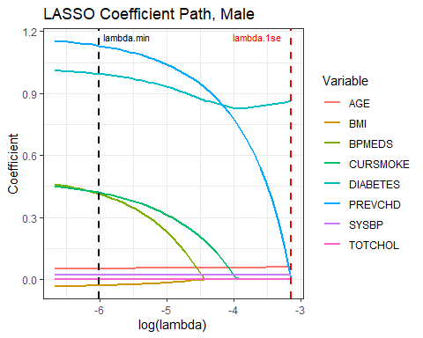
plot_lasso_path(fit_f_lasso, "Female")
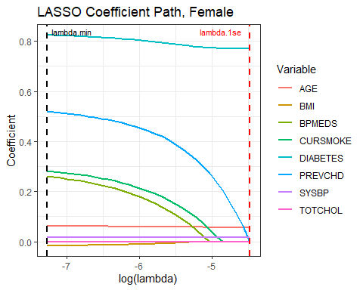
check_lambda <- function(lasso_list, s) {
coefs <- coef(lasso_list$cv, s = s)
pen <- lasso_list$penalized
data.frame(
variable = pen,
coef = round(coefs[pen, ], 4),
selected = coefs[pen, ] != 0
)
}
# Checking appropriate interim lambdas
# check_lambda(fit_m_lasso, s = exp(-5))
# check_lambda(fit_m_lasso, s = exp(-4))
# check_lambda(fit_f_lasso, s = exp(-6))
# check_lambda(fit_f_lasso, s = exp(-5))
fit_cox <- function(df, lasso_list, chosen_lambda) {
coefs <- coef(lasso_list$cv, s = chosen_lambda)
penalized <- lasso_list$penalized
forced <- lasso_list$forced
selected_penalized <- penalized[coefs[penalized, ] != 0]
final_vars <- c(forced, selected_penalized)
surv_eqn <- as.formula(
paste("Surv(time_stroke_yrs, censored) ~", paste(final_vars, collapse = " + "))
)
cox_fit <- coxph(surv_eqn, data = df, x = TRUE)
list(cox = cox_fit, selected = selected_penalized, vars = final_vars)
}
# Selected intermediate lambda values that keep variables with some signal
lambda_m <- exp(-4)
lambda_f <- exp(-5)
fit_m <- fit_cox(heart_male_complete, fit_m_lasso, lambda_m)
fit_f <- fit_cox(heart_female_complete, fit_f_lasso, lambda_f)
summary(fit_m$cox)
## Call:
## coxph(formula = surv_eqn, data = df, x = TRUE)
##
## n= 1897, number of events= 254
##
## coef exp(coef) se(coef) z Pr(>|z|)
## AGE 0.053576 1.055037 0.008196 6.537 6.28e-11 ***
## DIABETES 0.942955 2.567556 0.225365 4.184 2.86e-05 ***
## SYSBP 0.023334 1.023608 0.002698 8.648 < 2e-16 ***
## PREVCHD 1.187546 3.279025 0.164941 7.200 6.03e-13 ***
## CURSMOKE 0.505751 1.658231 0.135684 3.727 0.000193 ***
## ---
## Signif. codes: 0 '***' 0.001 '**' 0.01 '*' 0.05 '.' 0.1 ' ' 1
##
## exp(coef) exp(-coef) lower .95 upper .95
## AGE 1.055 0.9478 1.038 1.072
## DIABETES 2.568 0.3895 1.651 3.993
## SYSBP 1.024 0.9769 1.018 1.029
## PREVCHD 3.279 0.3050 2.373 4.530
## CURSMOKE 1.658 0.6031 1.271 2.163
##
## Concordance= 0.768 (se = 0.014 )
## Likelihood ratio test= 247.2 on 5 df, p=<2e-16
## Wald test = 288.5 on 5 df, p=<2e-16
## Score (logrank) test = 338.2 on 5 df, p=<2e-16
summary(fit_f$cox)
## Call:
## coxph(formula = surv_eqn, data = df, x = TRUE)
##
## n= 2378, number of events= 208
##
## coef exp(coef) se(coef) z Pr(>|z|)
## AGE 0.060475 1.062341 0.009916 6.099 1.07e-09 ***
## DIABETES 0.795011 2.214466 0.270797 2.936 0.00333 **
## SYSBP 0.015683 1.015806 0.002611 6.006 1.90e-09 ***
## PREVCHD 0.583585 1.792452 0.254584 2.292 0.02189 *
## CURSMOKE 0.333664 1.396074 0.148487 2.247 0.02463 *
## ---
## Signif. codes: 0 '***' 0.001 '**' 0.01 '*' 0.05 '.' 0.1 ' ' 1
##
## exp(coef) exp(-coef) lower .95 upper .95
## AGE 1.062 0.9413 1.042 1.083
## DIABETES 2.214 0.4516 1.302 3.765
## SYSBP 1.016 0.9844 1.011 1.021
## PREVCHD 1.792 0.5579 1.088 2.952
## CURSMOKE 1.396 0.7163 1.044 1.868
##
## Concordance= 0.72 (se = 0.018 )
## Likelihood ratio test= 153.6 on 5 df, p=<2e-16
## Wald test = 162.3 on 5 df, p=<2e-16
## Score (logrank) test = 186.3 on 5 df, p=<2e-16

Risk Profiles
plot_schoenfeld <- function(fit_list, sex_label) {
ph_test <- cox.zph(fit_list$cox)
var_names <- rownames(ph_test$table)
var_names <- var_names[var_names != "GLOBAL"]
global_p <- round(ph_test$table["GLOBAL", "p"], 3)
plots <- map(var_names, function(v) {
df <- data.frame(
time = ph_test$x,
resid = ph_test$y[, v]
)
ggplot(df, aes(x = time, y = resid)) +
geom_point(alpha = 0.4, size = 0.8) +
geom_smooth(method = "loess", se = TRUE, color = "darksalmon",
linewidth = 0.8) +
geom_hline(yintercept = 0, linetype = "dashed", color = "grey40") +
labs(title = v, x = "Time (years)",
y = "Scaled Schoenfeld Residual") +
theme_bw(base_size = 10)
})
title_plot <- ggdraw() +
draw_label(
sprintf("%s Schoenfeld Residuals (Global PH p = %.3f)",
sex_label, global_p),
fontface = "bold", size = 12
)
plot_grid(
title_plot,
plot_grid(plotlist = plots, ncol = 3, align = "hv"),
ncol = 1,
rel_heights = c(0.06, 0.94)
)
}
plot_schoenfeld(fit_m, "Male")
## `geom_smooth()` using formula = 'y ~ x'
## `geom_smooth()` using formula = 'y ~ x'
## `geom_smooth()` using formula = 'y ~ x'
## `geom_smooth()` using formula = 'y ~ x'
## `geom_smooth()` using formula = 'y ~ x'
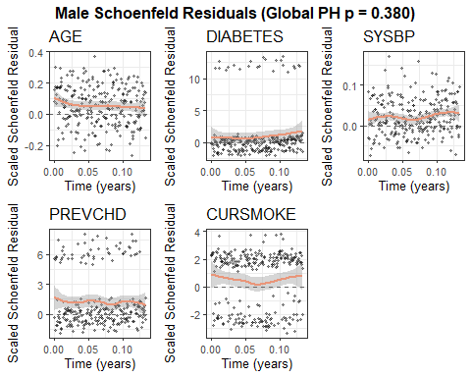
plot_schoenfeld(fit_f, "Female")
## `geom_smooth()` using formula = 'y ~ x'
## `geom_smooth()` using formula = 'y ~ x'
## `geom_smooth()` using formula = 'y ~ x'
## `geom_smooth()` using formula = 'y ~ x'
## `geom_smooth()` using formula = 'y ~ x'
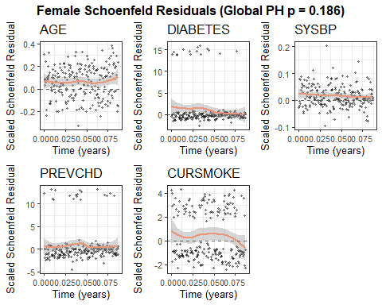
# Profiles: no risk factors, high SBP, diabetes, high SBP + diabetes, smoker
# Ages: 40, 50, 60
# Continuous vars set to sex-specific means, binary vars set to 0 at baseline
build_risk_table <- function(fit_list, dat, sex_label) {
cox_fit <- fit_list$cox
vars <- fit_list$vars
cont_vars <- intersect(c("AGE", "SYSBP", "TOTCHOL", "BMI"), vars)
bin_vars <- intersect(c("DIABETES", "PREVCHD", "BPMEDS", "CURSMOKE"), vars)
# Sex-specific continuous means
cont_means <- dat %>%
summarize(across(all_of(cont_vars), \(x) mean(x, na.rm = TRUE)))
make_profile <- function(age, overrides = list()) {
prof <- cont_means
for (b in bin_vars) prof[[b]] <- 0
prof[["AGE"]] <- age
for (nm in names(overrides)) {
if (nm %in% vars) prof[[nm]] <- overrides[[nm]]
}
prof %>% select(all_of(vars))
}
profiles <- list(
"No Risk Factors" = list(),
"High SBP (≥160)" = list(SYSBP = 160),
"Diabetes" = list(DIABETES = 1),
"High SBP + Diabetes" = list(SYSBP = 160, DIABETES = 1),
"Smoker" = list(CURSMOKE = 1)
)
map_dfr(c(40, 50, 60), function(age) {
map_dfr(names(profiles), function(pname) {
nd <- make_profile(age, profiles[[pname]])
sf <- survfit(cox_fit, newdata = nd)
sm <- summary(sf, times = 10)
prob <- 1 - sm$surv
lower <- 1 - sm$upper
upper <- 1 - sm$lower
risk_fmt <- ifelse(prob < 0.0001,
"<0.01%",
sprintf("%.2f%%", prob * 100))
ci_fmt <- ifelse(
prob < 0.0001,
"<0.01%",
paste0(sprintf("%.2f%%", lower * 100), ", ",
sprintf("%.2f%%", upper * 100))
)
risk_final <- paste0(risk_fmt, " (", ci_fmt, ")")
data.frame(
Age = age,
Profile = pname,
Risk = risk_final
)
})
}) %>%
pivot_wider(names_from = Age, values_from = Risk,
names_prefix = "Age ") %>%
rename(`Risk Profile` = Profile) %>%
flextable() %>%
set_caption(caption = sprintf("10-Year Stroke Probability, %s", sex_label))
}
build_risk_table(fit_m, heart_male_complete, "Male")
10-Year Stroke Probability, Male
Risk Profile | Age 40 | Age 50 | Age 60
No Risk Factors | 4.00% (2.70%, 5.28%) | 6.73% (5.09%, 8.34%) | 11.23% (8.44%, 13.94%)
High SBP (≥160) | 7.62% (4.97%, 10.19%) | 12.66% (9.52%, 15.70%) | 20.66% (16.01%, 25.05%)
Diabetes | 9.94% (4.97%, 14.66%) | 16.39% (9.32%, 22.90%) | 26.35% (15.58%, 35.75%)
High SBP + Diabetes | 18.41% (9.20%, 26.69%) | 29.37% (17.30%, 39.67%) | 44.79% (28.65%, 57.28%)
Smoker | 6.54% (4.91%, 8.14%) | 10.92% (9.10%, 12.69%) | 17.92% (14.33%, 21.36%)
build_risk_table(fit_f, heart_female_complete, "Female")
10-Year Stroke Probability, Female
Risk Profile | Age 40 | Age 50 | Age 60
No Risk Factors | 3.09% (2.02%, 4.14%) | 5.58% (4.37%, 6.77%) | 9.98% (7.81%, 12.11%)
High SBP (≥160) | 4.64% (2.87%, 6.38%) | 8.33% (6.41%, 10.21%) | 14.72% (12.00%, 17.35%)
Diabetes | 6.71% (2.64%, 10.62%) | 11.94% (5.61%, 17.85%) | 20.77% (10.12%, 30.16%)
High SBP + Diabetes | 9.98% (3.85%, 15.73%) | 17.52% (8.47%, 25.67%) | 29.71% (15.67%, 41.42%)
Smoker | 4.29% (2.93%, 5.63%) | 7.71% (5.98%, 9.40%) | 13.65% (10.02%, 17.14%)
plot_survival_curves <- function(fit_list, dat, sex_label, age) {
cox_fit <- fit_list$cox
vars <- fit_list$vars
cont_vars <- intersect(c("AGE", "SYSBP", "TOTCHOL", "BMI"), vars)
bin_vars <- intersect(c("DIABETES", "PREVCHD", "BPMEDS", "CURSMOKE"), vars)
cont_means <- dat %>%
summarize(across(all_of(cont_vars), \(x) mean(x, na.rm = TRUE)))
make_profile <- function(age, overrides = list()) {
prof <- cont_means
for (b in bin_vars) prof[[b]] <- 0
prof[["AGE"]] <- age
for (nm in names(overrides)) {
if (nm %in% vars) prof[[nm]] <- overrides[[nm]]
}
prof %>% select(all_of(vars))
}
profiles <- list(
"No Risk Factors" = list(),
"High SBP (≥160)" = list(SYSBP = 160),
"Diabetes" = list(DIABETES = 1),
"High SBP + Diabetes" = list(SYSBP = 160, DIABETES = 1),
"Smoker" = list(CURSMOKE = 1)
)
# survival curve for each profile
surv_df <- map_dfr(names(profiles), function(pname) {
nd <- make_profile(age, profiles[[pname]])
sf <- survfit(cox_fit, newdata = nd)
data.frame(
time = sf$time,
surv = sf$surv,
lower = sf$lower,
upper = sf$upper,
profile = pname
)
})
ggplot(surv_df, aes(x = time, y = 1 - surv, color = profile,
fill = profile)) +
geom_step(linewidth = 0.8) +
# geom_ribbon(aes(ymin = 1 - upper, ymax = 1 - lower),
# alpha = 0.15, color = NA) + # too crowded
scale_y_continuous(labels = scales::percent_format(),
limits = c(0, 0.45)) +
scale_x_continuous(breaks = seq(0, 10, 2)) +
labs(
title = sprintf("%s, Age %d", sex_label, age),
x = "Time (years)",
y = "Cumulative Stroke Probability",
color = "Risk Profile",
fill = "Risk Profile"
) +
theme_bw(base_size = 11) +
theme(legend.position = "bottom",
legend.text = element_text(size = 8))
}
# Individual plots
p1 <- plot_survival_curves(fit_m, heart_male_complete, "Male", 40)
p2 <- plot_survival_curves(fit_m, heart_male_complete, "Male", 50)
p3 <- plot_survival_curves(fit_m, heart_male_complete, "Male", 60)
p4 <- plot_survival_curves(fit_f, heart_female_complete, "Female", 40)
p5 <- plot_survival_curves(fit_f, heart_female_complete, "Female", 50)
p6 <- plot_survival_curves(fit_f, heart_female_complete, "Female", 60)
# Need to remove labels from each individual graph and then add it back at the end
# Don't want to mess with above code so make new function
strip_panel <- function(p, keep_x_axis = FALSE, keep_y_axis = FALSE) {
p +
theme(
legend.position = "none",
axis.title.x = if (keep_x_axis) element_text() else element_blank(),
axis.title.y = if (keep_y_axis) element_text() else element_blank()
)
}
p1s <- strip_panel(p1)
p2s <- strip_panel(p2)
p3s <- strip_panel(p3)
p4s <- strip_panel(p4)
p5s <- strip_panel(p5)
p6s <- strip_panel(p6)
shared_legend <- get_legend(
p1 + theme(
legend.position = "bottom",
legend.direction = "horizontal",
legend.title = element_text(size = 10, face = "bold"),
legend.text = element_text(size = 9)
)
)
panel_grid <- plot_grid(
p1s, p4s,
p2s, p5s,
p3s, p6s,
ncol= 2,
nrow= 3,
align= "hv",
label_size= 10,
label_x= 0.02,
label_y = 0.98
)
y_label <- ggdraw() +
draw_label("Cumulative Stroke Probability", angle = 90,
fontface = "plain", size = 11)
x_label <- ggdraw() +
draw_label("Time (years)", fontface = "plain", size = 11)
grid_with_y <- plot_grid(
y_label, panel_grid,
ncol = 2,
rel_widths = c(0.03, 0.97)
)
final_plot <- plot_grid(
grid_with_y,
x_label,
shared_legend,
ncol = 1,
rel_heights = c(0.88, 0.03, 0.09)
)
final_plot
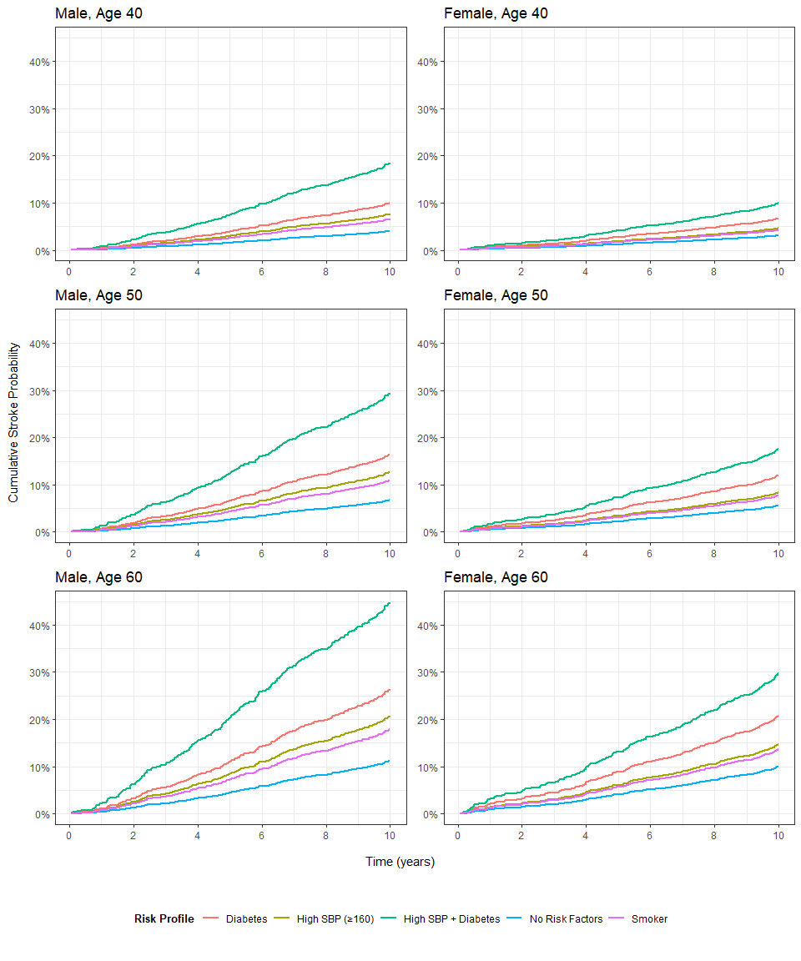

Time-Varying Analysis
heart_complete <- heart_raw %>%
group_by(RANDID) %>%
filter(n_distinct(PERIOD) == 3) %>%
ungroup()
complete_ids <- heart_complete %>%
filter(PERIOD == 1, PREVSTRK != 1) %>% # exclude only prevstrk in period 1
pull(RANDID)
heart_complete <- heart_complete %>%
filter(RANDID %in% complete_ids)
heart_1 <- heart_complete %>% filter(PERIOD == 1) # n = 3197 for all
heart_2 <- heart_complete %>% filter(PERIOD == 2)
heart_3 <- heart_complete %>% filter(PERIOD == 3)
time_var_tbl <- heart_complete %>%
tbl_summary(
by = PERIOD,
include = c(SYSBP, TOTCHOL, CURSMOKE, BMI, DIABETES,
BPMEDS, PREVCHD),
statistic = list(
all_continuous() ~ "{mean} ({sd})",
all_categorical() ~ "{n} ({p}%)"
),
digits = all_continuous() ~ 2,
label = list(
SYSBP = "Systolic BP",
CURSMOKE = "Smoker",
TOTCHOL = "Total Cholesterol (mg/dL)",
DIABETES = "Diabetes",
BPMEDS = "Blood Pressure Medication",
PREVCHD = "Coronary Heart Disease"
),
missing_text = "(Missing)"
) %>%
add_p(
test = list(
all_continuous() ~ "kruskal.test", # not adjusting for longitudinal, just simple descriptive
all_categorical() ~ "chisq.test"
)
)
time_var_tbl
Characteristic | 1 N = 3,197¹ | 2 N = 3,197¹ | 3 N = 3,197¹ | p-value²
Systolic BP | 130.12 (20.07) | 135.64 (21.59) | 140.19 (22.93) | <0.001
Total Cholesterol (mg/dL) | 235.41 (44.01) | 249.97 (44.93) | 236.56 (44.39) | <0.001
(Missing) | 32 | 109 | 210
Smoker | 1,522 (48%) | 1,391 (44%) | 1,094 (34%) | <0.001
BMI | 25.74 (3.97) | 25.86 (4.04) | 25.90 (4.08) | 0.2
(Missing) | 7 | 9 | 14
Diabetes | 58 (1.8%) | 105 (3.3%) | 250 (7.8%) | <0.001
Blood Pressure Medication | 77 (2.4%) | 275 (8.8%) | 414 (15%) | <0.001
(Missing) | 40 | 75 | 437
Coronary Heart Disease | 74 (2.3%) | 178 (5.6%) | 350 (11%) | <0.001
¹Mean (SD); n (%)
²Kruskal-Wallis rank sum test; Pearson's Chi-squared test

Hazard Ratio Table
make_hr_table <- function(fit_m, fit_f) {
tbl_m <- tbl_regression(
fit_m$cox,
exponentiate = TRUE,
label = list(
AGE = "Age",
SYSBP = "Systolic BP",
DIABETES = "Diabetes",
PREVCHD = "Coronary Heart Disease",
BPMEDS = "BP Medication",
CURSMOKE = "Current Smoker",
TOTCHOL = "Total Cholesterol (mg/dL)",
BMI = "BMI"
)
) %>%
modify_header(estimate = "**HR**")
tbl_f <- tbl_regression(
fit_f$cox,
exponentiate = TRUE,
label = list(
AGE = "Age",
SYSBP = "Systolic BP",
DIABETES = "Diabetes",
PREVCHD = "Coronary Heart Disease",
BPMEDS = "BP Medication",
CURSMOKE = "Current Smoker",
TOTCHOL = "Total Cholesterol (mg/dL)",
BMI = "BMI"
)
) %>%
modify_header(estimate = "**HR**")
tbl_merge(
tbls = list(tbl_m, tbl_f),
tab_spanner = c("**Male**", "**Female**")
) %>%
modify_caption("Hazard Ratios (95% CI) from Cox Proportional Hazards Models")
}
make_hr_table(fit_m, fit_f)
 | Male |  |  | Female
Characteristic | HR | 95% CI | p-value | HR | 95% CI | p-value
Age | 1.06 | 1.04, 1.07 | <0.001 | 1.06 | 1.04, 1.08 | <0.001
Diabetes | 2.57 | 1.65, 3.99 | <0.001 | 2.21 | 1.30, 3.77 | 0.003
Systolic BP | 1.02 | 1.02, 1.03 | <0.001 | 1.02 | 1.01, 1.02 | <0.001
Coronary Heart Disease | 3.28 | 2.37, 4.53 | <0.001 | 1.79 | 1.09, 2.95 | 0.022
Current Smoker | 1.66 | 1.27, 2.16 | <0.001 | 1.40 | 1.04, 1.87 | 0.025
Abbreviations: CI = Confidence Interval, HR = Hazard Ratio

Questions
– Clarify time frame: first ten years of follow-up? Yes, 3 periods? Use 365.25 * 10 as 10 years, don’t include period 3 (1st period only) – time 0, period 1, stroke 1 = stroke before – Competing risks (comment on limitations but don’t account for them) – Censor strokes after 10 years – exclusion criteria: prior stroke – Risk profile: know want to look at age, diabetes, systolic blood pressure; not sure about CHD, blood pressure meds, smoking, total cholesterol, BMI: baseline only –Want to keep as much data as possible –Risk profiles: estimates for 10-year survival for ages 40, 50, and 60 across baseline no risk factors (diabetes, SBP, maybe CHD, BP Meds, smoker, cholesterol, BMI: average continuous, 0’s on categoricals including BP meds); high blood pressure (SYS 160+); diabetes; high blood pressure and diabetes; 1 additional profile based on included covariates
–want survival prob for person of each profile –More interested in within-sex differences; not necessarily interested in between-sex –PH assumption: Look at for everything
only descriptive time varying on diabetes and sys BP 2 separate models for M/F (diff covariates, etc.)
Null: HR = 1 for each of age, diabetes, sys BP 367 competing deaths, 111 strokes; standard cox model treats deaths as censored, which overestimates cumulative stroke incidence
Should be 32 excluded for stroke Table 1 —- Stroke during follow up Follow up Time
n = 4275 (127 missing) no need to exclude high BP & cholesterol
Table 1 Results Table M Results Table F K-M plot (6 panels, age, BP, etc) Cox PH (6 panels?)

